# Scheduling and Estimates

The schedule is managed using Excel as a scheduling tool, it can easily create and change the schedule using formulas, and the resources are managed using Word document. The schedule can be found on the team’s GitHub repository and Google Drive.

## Project Schedule

The project schedule is set within the NWU semester period, this includes recess. The schedule needs to be able to adapt to unexpected changes. The schedule is set around the Agile Methodology, allowing the schedule to be easily changed. See a sample of the schedule below.

Excel is used as a schedule management tool. The screenshot below is a sample of the screenshot. It includes all the tasks and iterations.

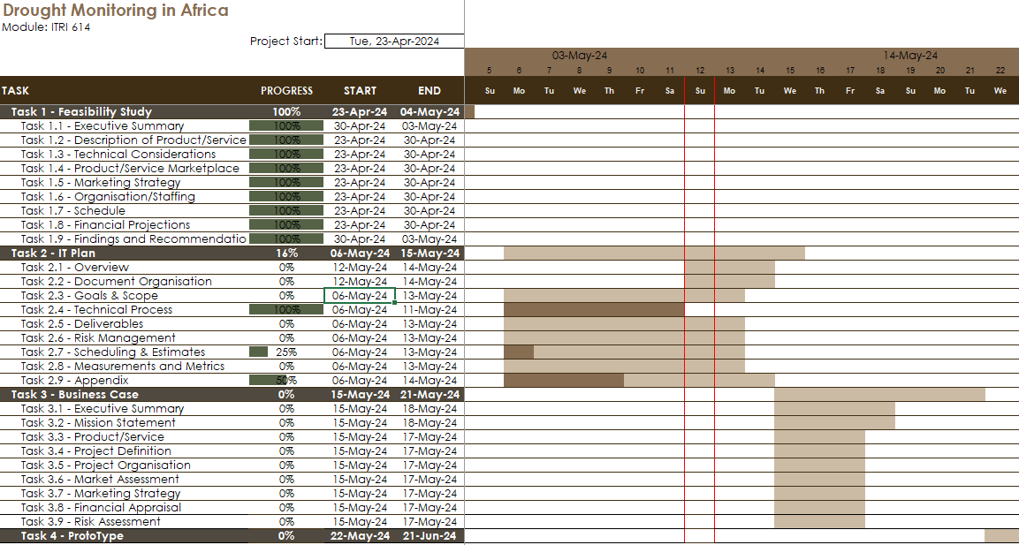

Figure 1: Gantt chart in Excel.

## Work Breakdown Structure

Work breakdown structure (WBS) is when large tasks are divided into smaller manageable tasks. The technique, commonly used in productivity techniques, displays tasks in a hierarchical view of high-level tasks, with the sub-tasks, in the projects.

The image below is the WBS of the project, it will change overtime as tasks are added or removed . The WBS is visually depicted using Draw.io, and the tabular structure is in the same Excel file as the Gantt file.

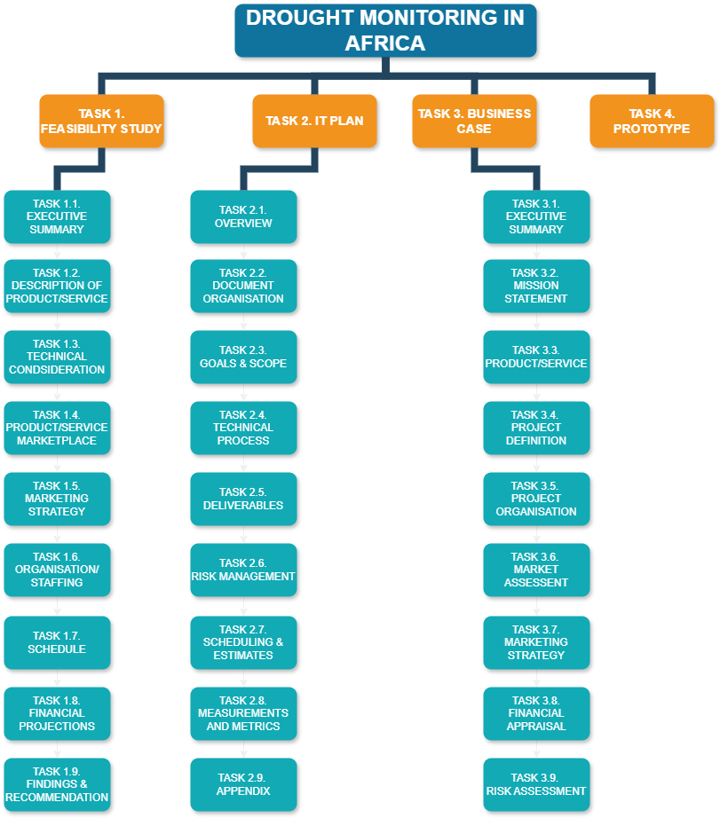

Figure 2: Work Breakdown Structure (WSB) for project.

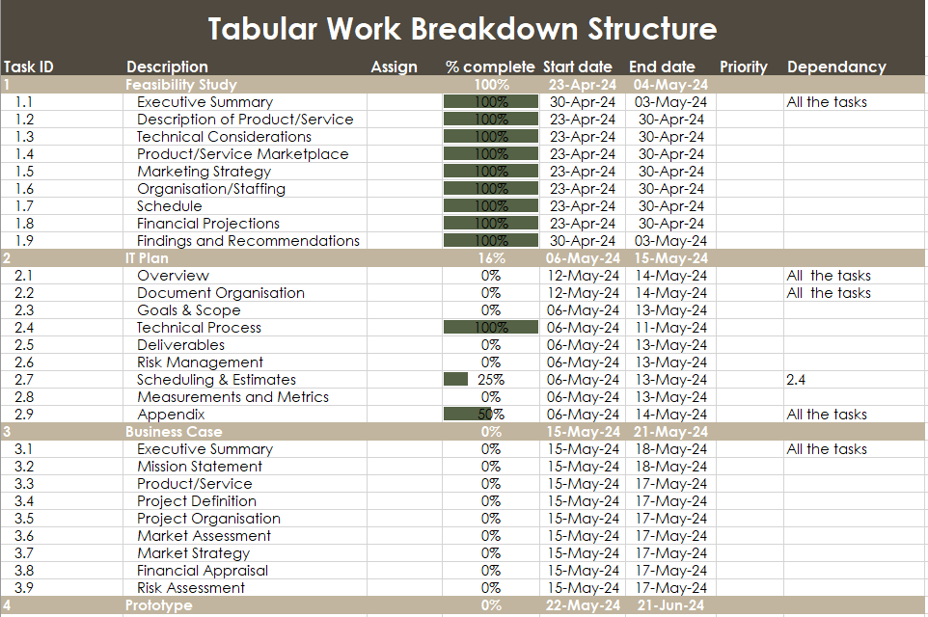

Figure 3: Tabular WBS for the project.

The tabular WBS uses the data from Gantt chart and the data will synchronize when progress is made to the Gantt chart. If a task is updated, it will reflect in the WBS table. If any task is update it will need to be manually changed.

## Resource Allocation

All the resources for this project will be managed in GitHub.

The resources available are the personal resources that each team member possesses. These team members include Oratile Seloro, Sarah Masu, Chriselda Mathebula, Mduduzi Msiza, Wilco Tromp, Jevon Gounden, Rorisang Serapelo and Melissa Roodt.

Currently the hardware resources consist of the team member’s personal laptop/desktops and mobile devices for development and testing.

The software resources that are available are python, MATLAB, and existing South African drought data.

To allocate the resources, GitHub is used. An example of the resource allocation is below in figure 4. The link to the GitHub repository is [here](https://github.com/rorisang123/ITRI614-2024).

Figure 4: GitHub resource allocation

## Estimates

The estimations will be done on GitHub and in the Scheduling excel document. The estimations incorporate the time taken to complete a task, the tasks, and the sprints of the project. An example of the estimations is shown in figure 5.

Figure 5: GitHub resource allocation

## Tracking and Schedule Changes

All of the tracking and schedule changes will be controlled by GitHub and Microsoft excel.

# References

Duke, R., n.d. *What is a Workdown Structure?.* [Online]   
Available at: https://www.workbreakdownstructure.com/  
[Accessed 11 May 2024].

Kukhnavets, P., 2024. *How to Create a Work Breakdown Structure (WBS) in Excel: a Detailed Guide [Alternative Included].* [Online]   
Available at: https://blog.ganttpro.com/en/how-to-create-wbs-in-excel/  
[Accessed 12 March 2024].